# CS 340 README Template

*Use this template to complete your README file. When completing the template, keep the headings as they are so that your document has a clear organization. Remove the italicized prompt text after you have completed each section for a polished final document.*

## About the Project/Project Title

Grazios Animal Shelter Database UI.

This project is designed to allow users the ability to search through the Grazios database of shelter animals. It will also allow the user to see the circumstances of how they came into the Grazios system along with different attributes/characteristics of each animal that is searched.

## Motivation

Grazioso Salvare had reached out to our company, Global Rain, to create an opensource application that will utilize pre-existing information to help identify different dogs from shelters to be trained in search-and-rescue procedures. The motivation behind this is to help give shelter animals an opportunity to be useful and loved.

This system is being designed to stream line the process of finding potential candidate dogs to go through the search-and-rescue program, as opposed to calling the shelters and having to coordinate meeting times. This will allow the user to search the constantly updating database between the partner shelters for candidates without disrupting workflow to the degree that is currently being had.

## Getting Started

To get started, the MongoDB database needs to be set up with authentication through creating user profiles and passwords. Once created, the credentials can be shared with partnering shelters to update the database as animals are onboarded and offboarded.

## Installation

Download libraries and source code from repository.

Python 3.6 or later is needed to run the program.

Pymongo package 1.4 or later

ObjectId package

## Usage

*Use this space to show useful examples of how your project works and how it can be used. Be sure to include examples of your code, tests, and screenshots.*

### Code Example

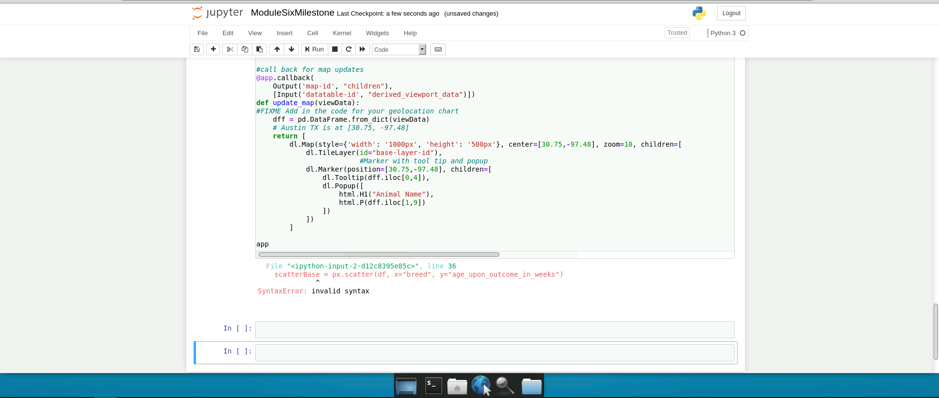

**Tests**

*Unable to provide testing due to program not running because of apparent syntax errors.*

### Screenshots

*Unable to provide screenshots due to program not running because of apparent syntax errors.*

## Contact

Scott Baker